Yes, I expect you search the Java API for useful methods as needed! All your answer must be within 0.005 to be considered correct.

- Implement the following recursive function using integer math.
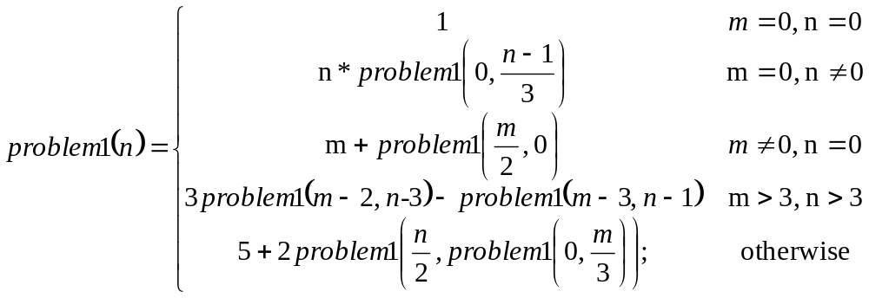

public static int problem1(int n, int m)

Test data: problem1(10, 3) returns 43

- Implement the following rational function.
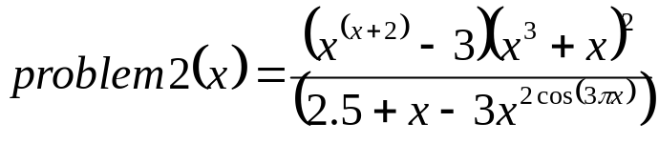
using the following function heading:
public static double problem2(double x)

Test data: problem2(-5) returns 19402.74809

- Implement the following function.
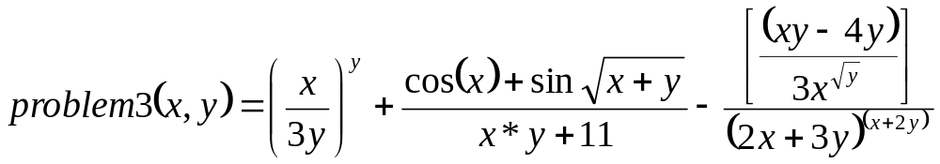
using the following function heading:
public static double problem3(double x, double y)

Test data: problem3(10, 1) returns 3.2850

- Implement the following function

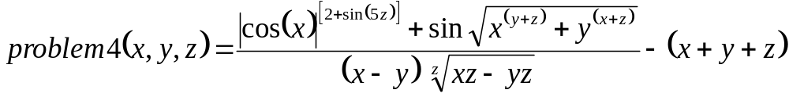
Recall that 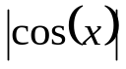 is the absolute value of the cos(x).

Use following function heading:
public static double problem4(double a, double b)

Test data: problem4(5, 2, 5)) returns -12.172968

- Implement the following function
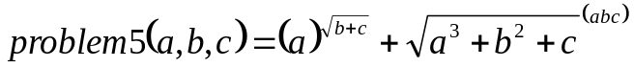
Use following function heading:
public static double problem5(double a, double b, double c)

Test data: problem5(7./3, 2., 0.5)) returns 31.45921

- Implement the following function
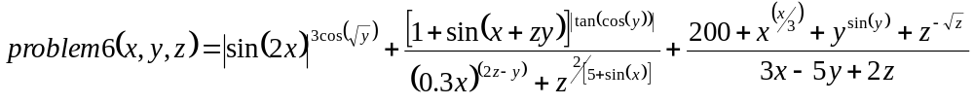
Recall 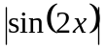 is the absolute value of sin(2x) and 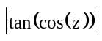 is the absolute value of tan(cos(z)).
Use following function heading:

public static double problem6(double x, double y, double z)

Test data: - problem6(3.1, 2.4, 1.9)) returns 188.46168

- implement the following function
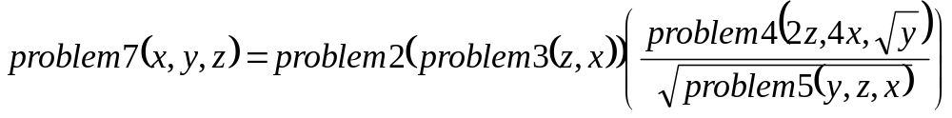
Use following function heading:
public static problem7(double x, double y, double z)

Test data: - problem7(0.9, 1, 1.1)) returns 4.0705124

- Implement the following function
Recall 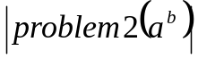 is the absolute value of 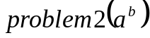 and 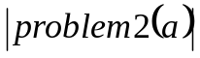 is the absolute value of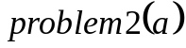
Use following function heading:
public static double problem8(double a, double b)

Test data: - problem8(0.7, -0.5) returns 13.344057809

- Implement the following function
Use following function heading:
public static double problem9(double a, double b,
double x, double y, double z)

Test data: - problem9(1, 2, 3, 4, 5)) returns 106378.58236

- Implement the following function
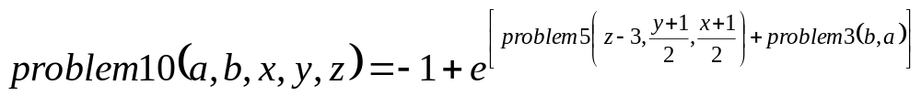
Use following function heading:
public static double problem10(double a, double b,
double x, double y, double z)

Test data: - problem10(6, 20, 3, -5, 3) returns 47.314003208

